
Green University of Bangladesh
Department of Computer Science and Engineering (CSE)
Faculty of Sciences and Engineering
Semester: (Fall, Year: 2025), B.Sc. in CSE (Day)

Lab Report NO: 03
Course Title: IDP 1
Course Code: CSE 308
Section: 232-D2

Lab Experiment Name: Darw the DFD level 0,1, and 2 diagram for your project.\

Student Details

Name |  | ID
1.  2.  3. | Modabbir Mohammad Mansur  Ashab Uddin  Rukonuzzaman Topu | 232002154  232002274  232002280

Lab Date : 02/11/2025
Submission Date : 23/11/2025
Course Teacher’s Name : Sharifur Rahman

Lab Report Status
Marks: ………………………………… Signature: .....................
Comments: .............................................. Date: ..............................

1. INTRODUCTION

In this part of the experiment, we broke down the LifeLink system into multiple levels to understand how information moves through the processes. The diagrams were prepared separately, and here we describe what each level represents.

2. OBJECTIVES

• To identify the main data movement across the LifeLink system.
• To break down system processes into structured levels using DFD techniques.
• To explain how patient, doctor, admin, and external modules exchange data with the system.
• To understand internal processing steps for registration, prediction, recommendation, and health tracking.

3. PROCEDURE

In this experiment, we carried out the following steps:
- Identified all external entities (Patient, Doctor, Disease Database, Prediction Model).
- Analyzed the overall workflow of LifeLink to create the Level 0 DFD.
- Broke the system into major subsystems for the Level 1 DFD.
- Expanded each major subsystem into smaller processes for Level 2 DFD.
- Documented all data flows, inputs, outputs, and data stores.
- Prepared diagrams.
4. IMPLEMENTATION
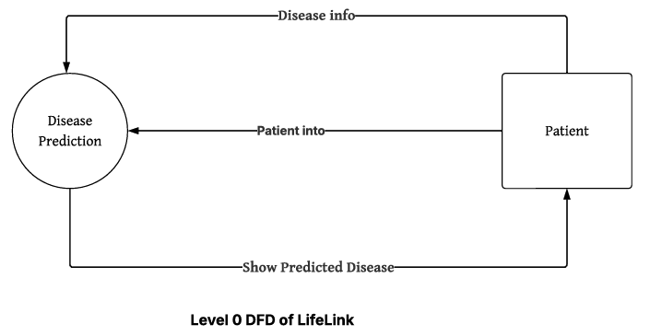
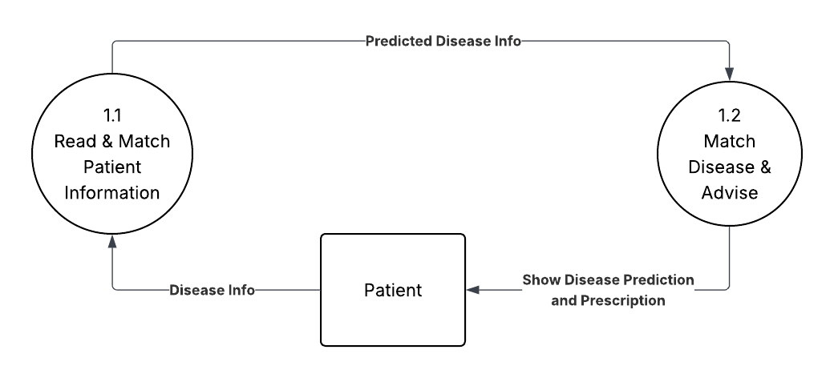
Level 1 DFD of LifeLink

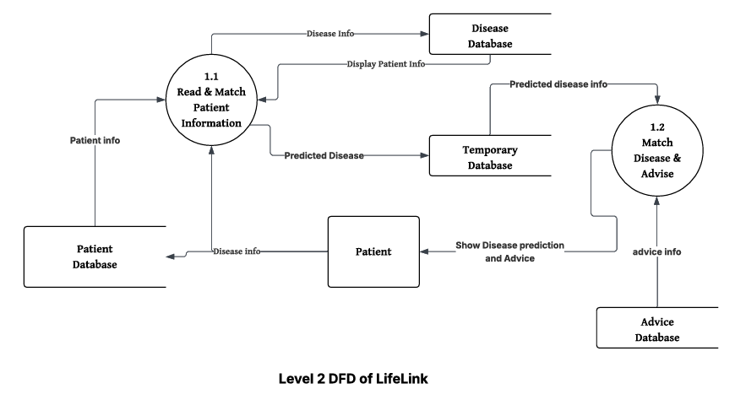

6. ANALYSIS AND DISCUSSION
While we create DFD diagram, we understand how to handles major tasks of LifeLink like it is going to match the patient old and new data. Then it predict the disease and return to match the disease with the database to find the perfect prescription. Breaking the system into multiple levels helped show both the high-level flow and the deeper internal processes.
The structured data movement highlights where information is stored, how it is processed, and how different users interact with the system. This breakdown ensures better planning for future development, improves clarity, and reduces complexity when designing the system architecture.

